**Technical & Functional analysis**

**Breakout game with accelerometer controller using Thread/Matter**

|  |  |
| --- | --- |
|  |  |

Date :

Contacts : Dekimo :

Table of Contents

1. Project overview 3

1.1. Matter protocol 3

1.2. OpenThread network protocol 3

2. Game controller 4

2.1. EFR32MG24 - BRD2601B Dev Kit 4

2.2. EFR32MG24 Wireless SoC 5

2.3. ICM-20689 6-Axis sensor 6

2.4. User Button 7

3. SBC 8

4. Thread 8

4.1. Rights – OpenThread – Thread 8

5. Matter protocol – specification 10

5.1. Terms 10

5.2. Architecture 11

5.2.1. Network 11

5.2.2. Device Data Model 14

6. Document Information 17

6.1. Version History 17

6.1. Related Documents 18

# Project overview

This project is an interactive breakout game controlled by motion with a wireless controller. The controller is connected to a Thread network and communicates with the Matter protocol. The breakout game is displayed on a tv using a SBC (Single Board Computer) that is also connected to a Thread network.

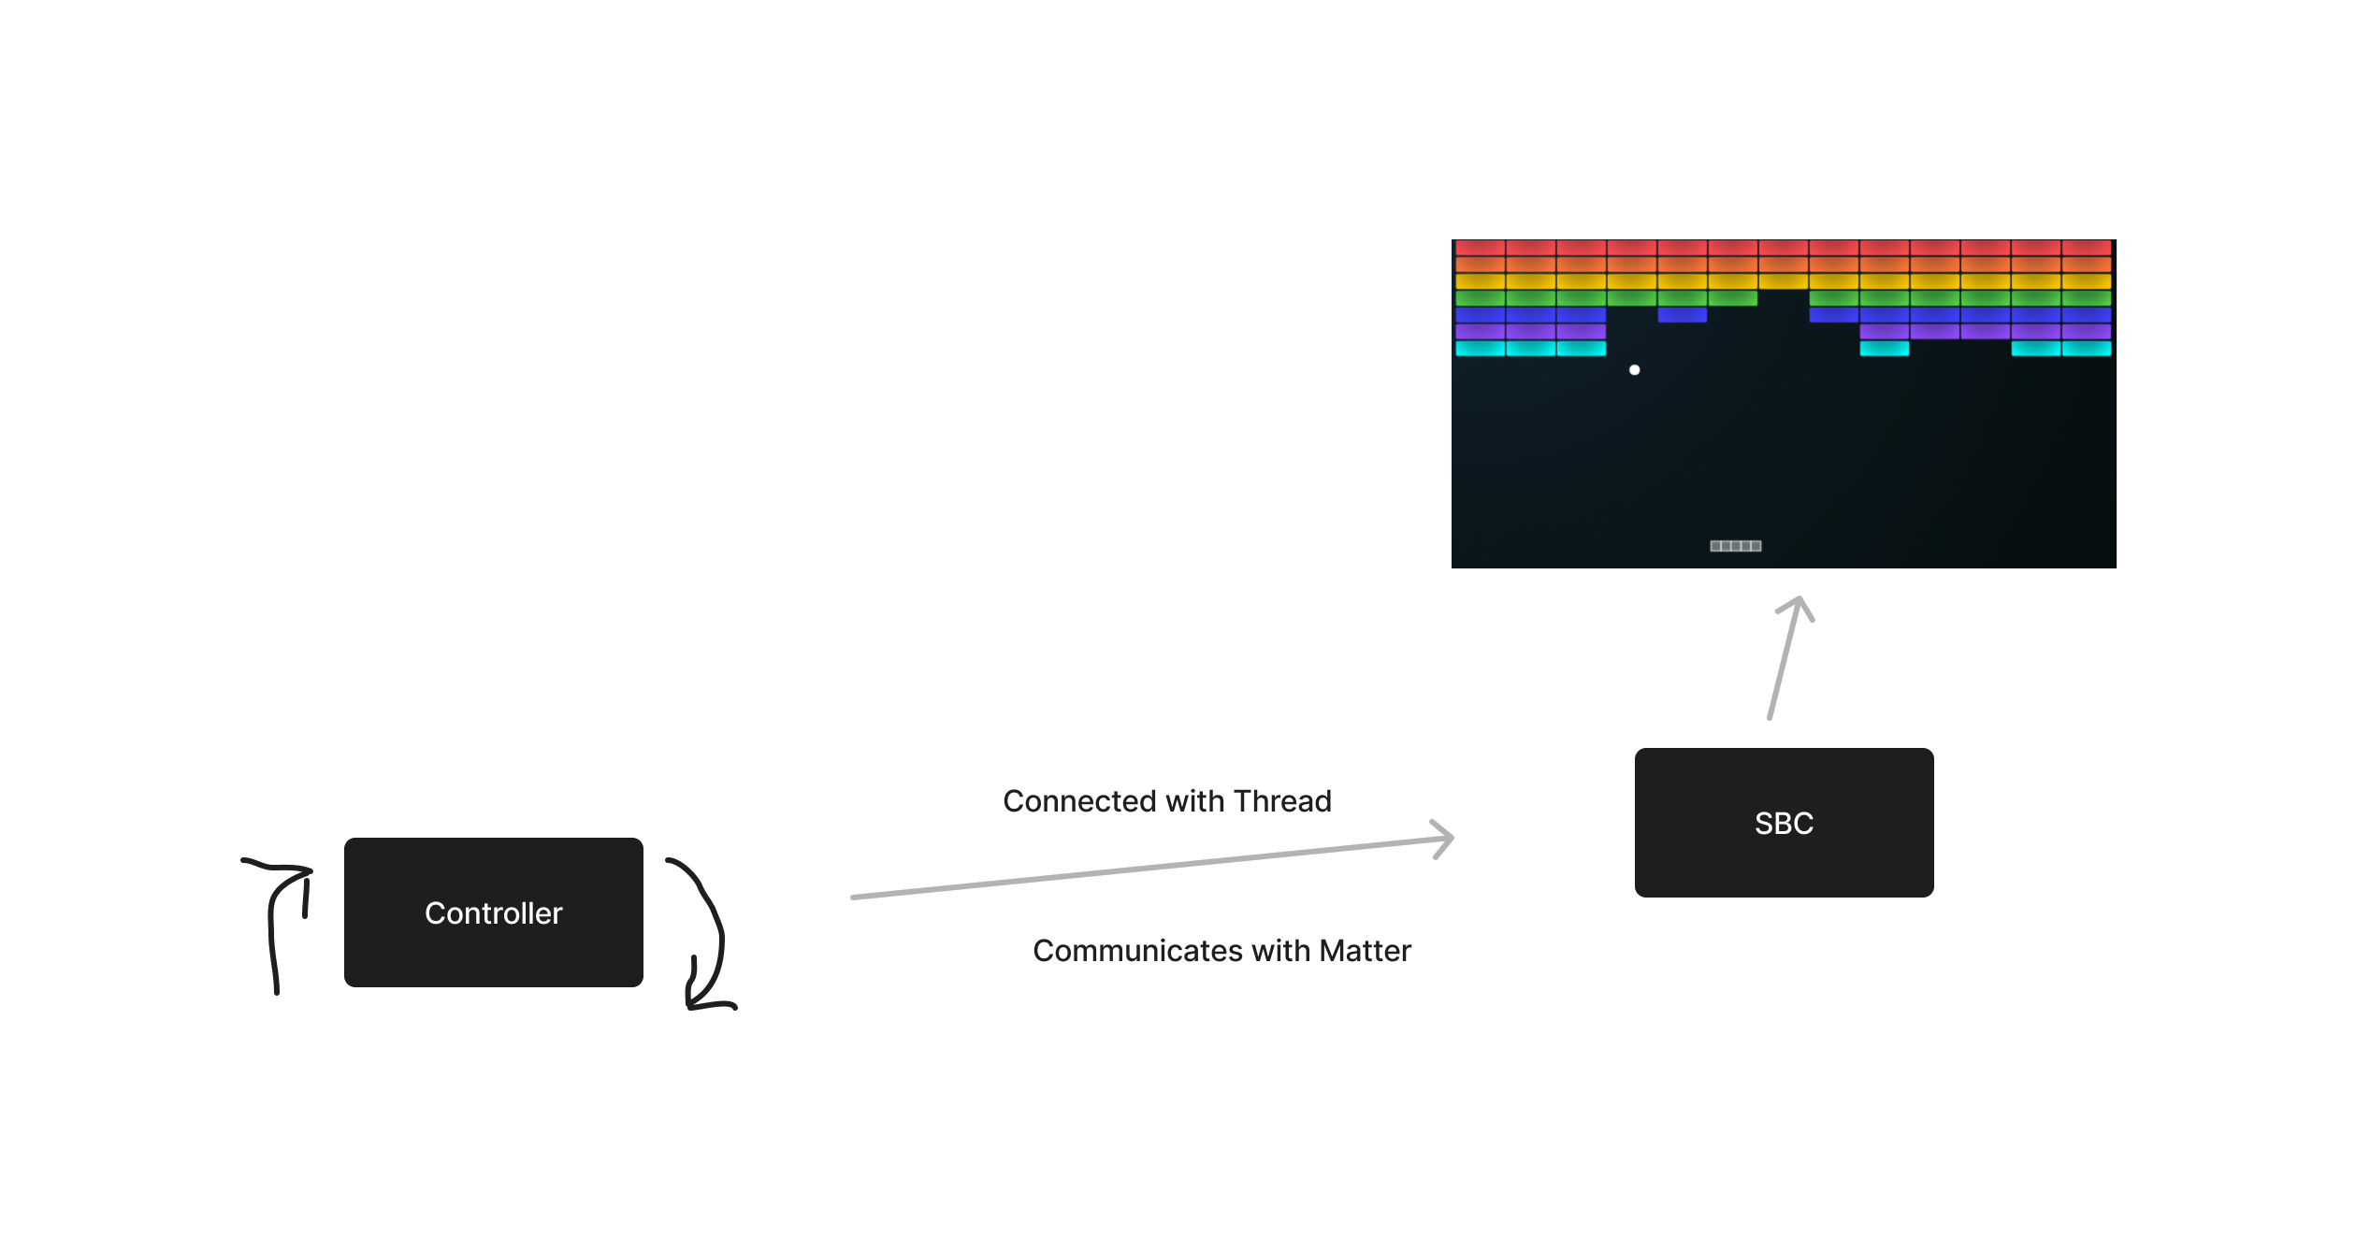

## Matter protocol

Matter, formerly known as “Project CHIP” (Connected Home over IP) is an open-source, royalty-free connectivity standard designed to make it easier for various smart devices to communicate with each other. It aims to create a unified standard for the Internet of Things devices. A Matter device can connect to a network with Thread, WIFI and Ethernet.

## OpenThread network protocol

OpenThread is an low-power mesh networking protocol that is based on IPv6. OpenThread is a open standard and is built for IoT applications. It uses 6LoWPAN which uses IEEE 802.15.4 (2.4Ghz) wireless protocol with mesh communication.

# Game controller

The wireless controller must be equipped with:

* 2.4Ghz wireless controller used for the OpenThread connection
* Accelerometer used to interact with the game (moving the bar)
* Button used for interact with the game (pause, start, etc.)
* A battery to provide power to the controller

## EFR32MG24 - BRD2601B Dev Kit

The EFR32MG24 Dev Kit board (BRD2601B) supports al the elements that is necessary for the controller. So there is no need to develop a PCB with al this components.

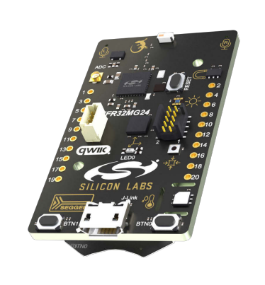 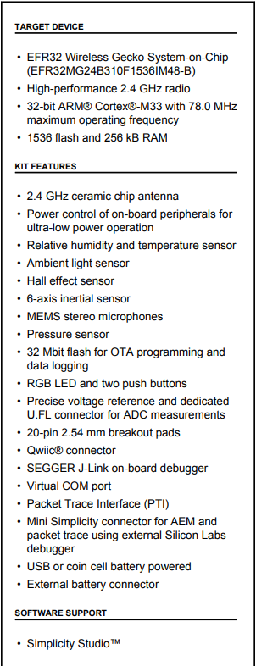

## EFR32MG24 Wireless SoC

The development board uses the EFR32MG24 wireless SoC (System on a Chip). This SoC is ideal for meshing wireless solutions using Matter and OpenThread. It provides al the built in features that are relevant for this project, like:

* High performance 32-bit 78 MHz Arm Cortex®-M33 processor
* 1536 kB flash and 256 kB of RAM
* High performance 2.4GHz Radio
* OpenThread and Matter support
* Security features for protection against hardware and software attacks
* A wide range of peripherals like I²C, SPI, USART, ADC, Timers, GPIO’s, etc.

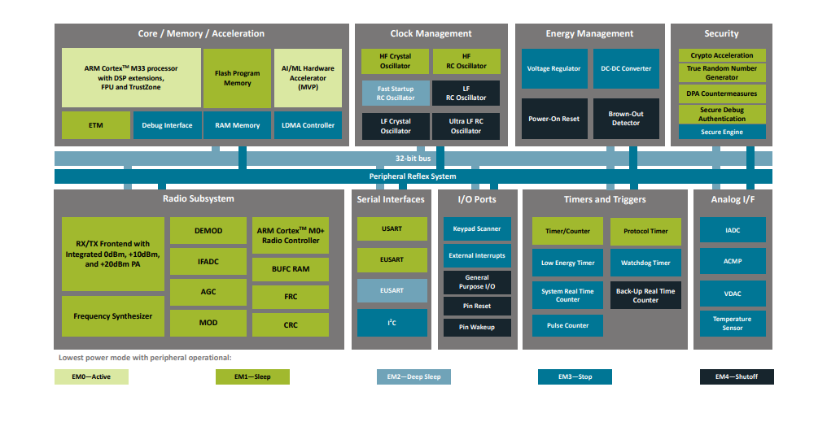

## ICM-20689 6-Axis sensor

The development board contains a 6-axis sensor ICM-20689. This 6-axis sensor combines a 3-axis gyroscope and a 3-axis accelerometer. It detects acceleration and angular rate in the X, Y and Z axes.

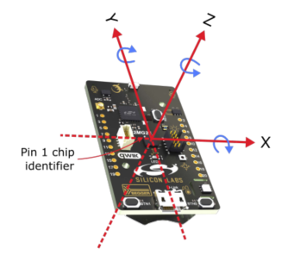

In the development board the sensor is connected an communicates over SPI. The SPI lines are interrupted trough a switch to prevent power consumption when not used. Before the sensor can be used in the application it must be enabled by setting PC09 high.

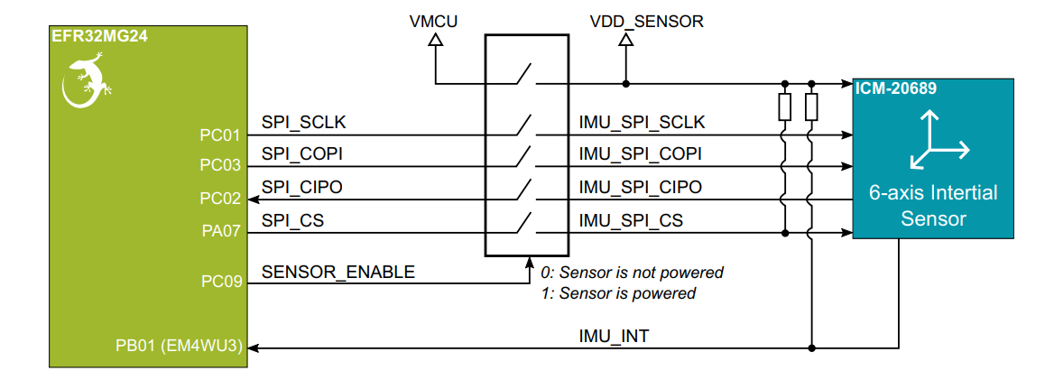

## User Button

The development board has two user buttons, BTN0 and BTN1. They are directly connected to the EFR32MG24 SoC and are debounced by RC filters.

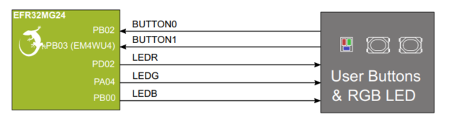

The buttons are connected to the pins PB02 and PB03. The pins are also available on the expansion header. The buttons on the board can be used during the development and later on we can use buttons in a case that are connected to the expansion header.

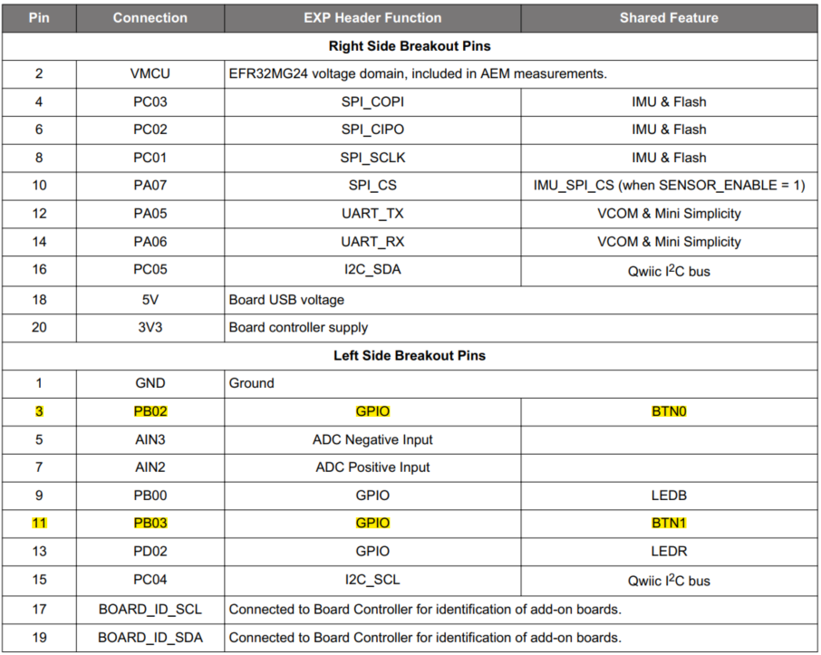

# SBC

# Thread

## Rights – OpenThread – Thread

**Needs to modify in own words**

What Is OpenThread?

OpenThread is an open-source implementation of the Thread networking protocol technology developed and released by Google and maintained on GitHub.

Close Answer

What Is The Difference Between Thread And OpenThread?

OpenThread released by Google is an open-source implementation of Thread technology. Developers who choose to implement OpenThread in shippable products must join the Thread Group in order to certify those products and market them as Thread-certified.

Close Answer

Is An End-Product Based On OpenThread Automatically Thread-Certified?

No. If a company uses OpenThread to build a product, they need to be a member of the Thread Group in order to gain the Intellectual Property (IP) rights to ship Thread products and to complete product certification, which ensures that products using Thread work together effortlessly and securely right out of the box.

Close Answer

What Would Prevent A Company From Shipping A Product Based On OpenThread Without Joining The Thread Group?

If developers choose not to join Thread Group and ship products using Thread technology, they are not conferred the IP rights required to practice and ship Thread technology, and may subject themselves to legal action, including but not limited to licensing fees.

# Matter protocol – specification

## Terms

In order to understand this Matter document we need to know the definitions of several terms.

|  |  |
| --- | --- |
| **Term** | **Definition** |
| Device | A piece of equipment containing one or more Nodes |
| Node | An addressable entity which supports the Matter protocol stack and has its own Operational Node ID and Node Operational credentials. A Device may host multiple Nodes. |
| Endpoint | A particular component within a Node that is individually addressable. |
| Fabric | A logical collection of communicating Nodes, sharing a common root of trust,and a common distributed configuration state. |
| Cluster |  |
|  |  |
|  |  |
|  |  |
|  |  |
|  |  |
|  |  |
|  |  |
|  |  |
|  |  |
|  |  |

## Architecture

### Network

Matter is a universal IPv6-based communication protocol designed for smart home and the Internet of Things devices. Matter works on the Application Layer of the Network Stack.

Matter Protocol Stack

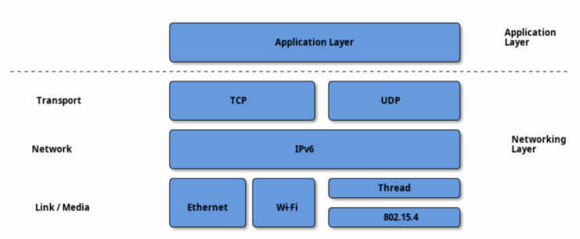

The Matter protocol stack is divided into layers to separate the different responsibilities and introduce a good level of encapsulation amongst the various parts of the protocol stack.

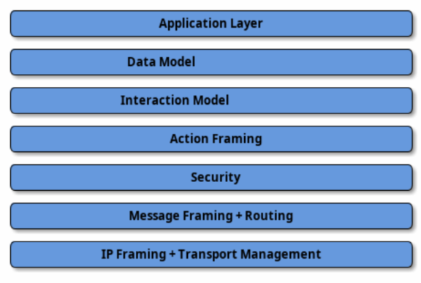

* **Application Layer:** High-order business logic of a device. For example, an application that is focused on lighting might contain logic to handle turning on/off the light as well as its color characteristics.
* **Data Model:** The data layer corresponds to the data and verb elements that help support the functionality of the application. The Application operates on these data structures when there is an intent to interact with the device.
* **Interaction Model:** The Interaction Model layer defines a set of interactions that can be performed between a client and server device. For example, reading or writing attributes on a server device would correspond to application behavior on the device. These interactions operate on the elements defined at the data model layer.
* **Action Framing:** Once an action is constructed using the Interaction Model, it is serialized into a prescribed packed binary format to encode for network transmission.
* **Security:** An encoded action frame is then sent down to the Security Layer to encrypt and sign the payload to ensure that data is secured and authenticated by both sender and receiver of a packet.
* **Message Framing & Routing:** With an interaction encrypted and signed, the Message Layer constructs the payload format with required and optional header fields; which specify the message's properties and some routing information.
* **IP Framing & Transport Management:** After the final payload has been constructed, it is sent to the underlying transport protocol for IP management of the data.

Network Topology

In principle, any IPv6 network is suitable for Matter deployment butt the focus is on three link layer technologies: Ethernet, Wi-Fi and Thread.

Matter treats networks as shared resources: it makes no stipulation of exclusive network ownership or access. As a result, it is possible to overlay multiple Matter networks over the same set ofconstituent IP networks.

This protocol may operate in the absence of globally routable IPv6 infrastructure. This requirementenables operation in a network disconnected or firewalled from the global Internet. It also enablesdeployment in situations where the Internet Service Provider either does not support IPv6 on consumer premises or where the support proves otherwise limiting.

This protocol supports local communications spanning one or more IPv6 subnets. Canonical networks supporting a fabric may include a Wi-Fi/Ethernet subnet, or one or more low power and lossy network (LLN) subnets. In this version of the specification, Thread is the supported LLN standard.

**Single network**

In the single network topology, all Matter devices are connected to a single network. This could by a Thread network, Wi-Fi or Ethernet network. In the case of WiFi/Ethernet, the network could in fact span multiple Wi-Fi and/or Ethernet segments provided that all the segments are bridged at the link layer.

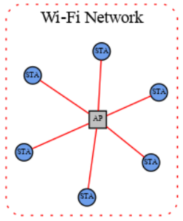

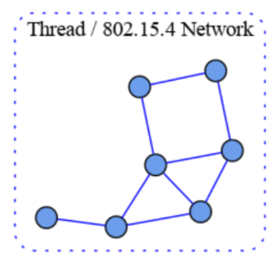

**Star network topology**

The star network topology consists of multiple peripheral networks joined together by a single hub network. The hub network will be the customer’s home network. while the peripheral networks can be of any supported network type. A peripheral network must always be joined directly to the hub network via one or more Border Routers.

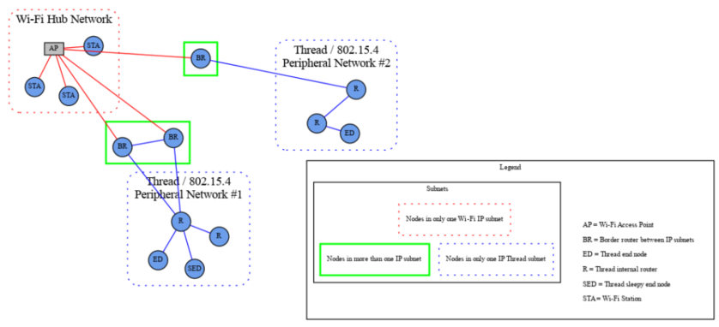

In the star network topology any number of peripheral network may be present in a single fabric, including networks of the same type. Nodes may have interfaces onto any network and can communicate directly to other nodes on the same network. If a node needs to cross a network to communicate it must flow through a Border Router.

This protocol places a set of requirements on the Border Router. These requirements pertain to

address assignment, route assignment and advertisement, multicast support, and discovery proxying.

### Device Data Model

The data model in Matter is a hierarchical modeling of a devices features.

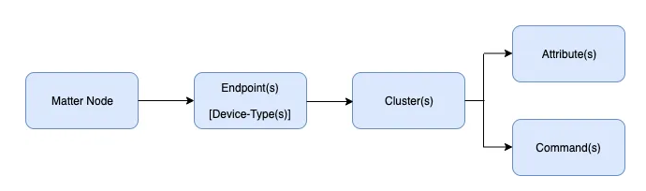

**Node**

This is a uniquely network addressable entity that exposes some functionality. This is typically a physical device that a user can recognize as a whole device. The role of a node is a set of related behaviors. A node can contain one or more roles including:

* Commissioner: Refers to the process of assigning Fabric credentials to a new device.
* Controller: A node that can control one or more nodes such as a On/Off switch
* Controlee: A node that can be controlled by one or more nodes. Such as a actor. Devices that have the controller role cannot be a controlee.
* OTA Provider: Provides OTA software updates.
* OTA Requestor: Requests OTA software updates.

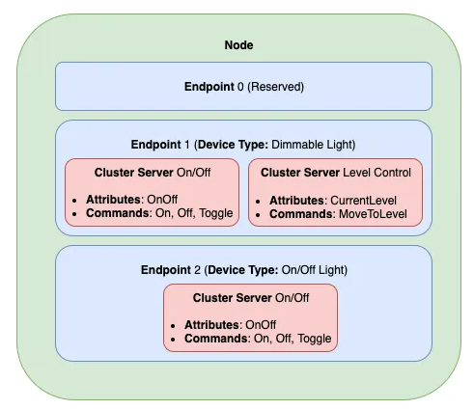

**Endpoint**

Each node has one ore more endpoints. A endpoint contain a set functionality’s of a single device. In the example above endpoint 1 is a dimmable light that have the functionality turning on or off AND have a functionality level control, that controls the brightness of the light. Endpoint 2 have only the functionality turning on or off. Note that endpoint 0 is reserved for utility functions.

**Clusters**

In chapter 7.10.4 "New Cluster," it appears that there is a possibility to create a new cluster. It might be worth investigating this.

A cluster groups together commonly used functionality in a reusable building block. Endpoint 1 has two cluster which describes their own functionality. Within the clusters they contain:

* Attributes: Attributes are data entities that represent a physical quantity or state. Each attribute is listed in a table with data quality columns: ID, Name, (Data) Type, Constraint, other Quality, Access, Default (value), and Conformance. An attribute also defines its associated semantics and behavior.

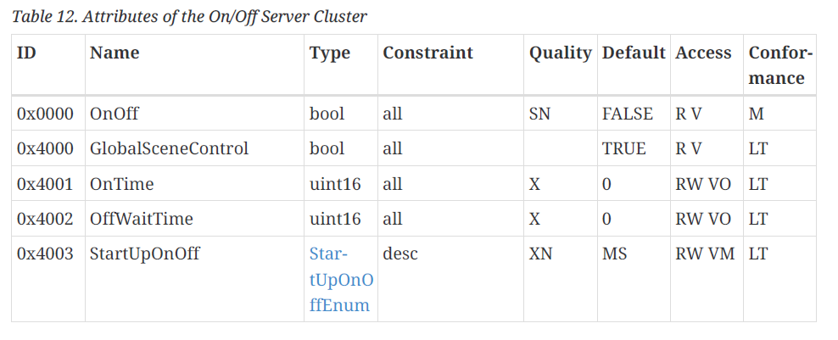

* Commands: A cluster command provides an ability to invoke a specific behavior on the cluster. A command may have parameters that are associated with it. Each command SHALL be listed in a table with data quality columns: ID, Name, Direction, Response, Access, Conformance. The command table SHALL define the direction of the command as either client to server or server to client. The command table SHALL define the access privileges for each request command or omit the privileges for the default.

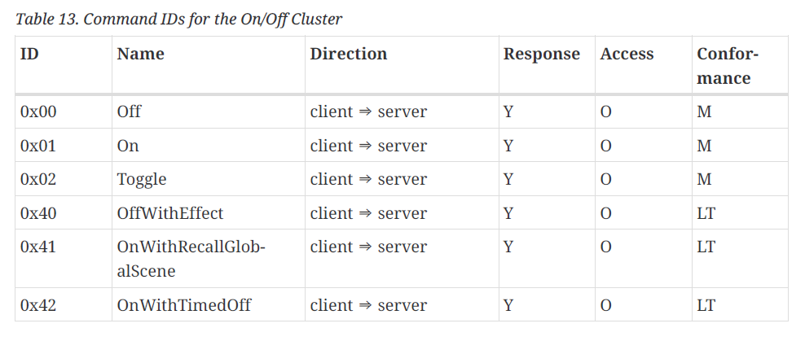

The clusters that are supported can be found at the **matter-1-1-application-cluster-specification.pdf** document.

**Events**

Events are a type of attributes that communicate device state changes. They can also be treated as historical data records of something that happened on the device in the past.

**Cluster Client / Server**

A cluster server is stateful and holds attributes, events and commands while a client is stateless and is responsible to initiate interactions with a cluster server.

**Device Type**

A Matter device type is an officially defined collection of requirements for one or more endpoints. Device types are intended to ensure interoperability of different device brands on the market. Each device type definition is composed of the following elements:

* Device type ID
* Device type revision
* One or more mandatory clusters, including each cluster’s minimum revision

All the device types are defined in the 22-27351-002_matter_1-1-device-library-specification.pdf document.

# Document Information

## Version History

|  |  |  |  |
| --- | --- | --- | --- |
| **Date** | **Author** | **Version** | **Description** |
| 22/09/2023 | BGY | 0.1 | Project overview and wireless controller description |
|  |  |  |  |
|  |  |  |  |
|  |  |  |  |
|  |  |  |  |
|  |  |  |  |
|  |  |  |  |

## Related Documents

|  |  |
| --- | --- |
| **Ref** | **Description** |
| 22-27349-002_matter-1-1-core-specification.pdf | Full specification document of the Matter protocol. |
|  |  |
| matter-1-1-application-cluster-specification.pdf | Supported application cluster specification. |
|  |  |
| 22-27351-002_matter_1-1-device-library-specification.pdf | All the device types are defined in this document. |
|  |  |